
Habib University
School of Science & Engineering
Student Name/ID
Course: | EE – 211 – Basic Electronics
Semester | Spring 2024
Midterm # | 1
Date, Time, Location : | April 15, 2024, 0830-0930,  H-509
Instructor : | Syed Arsalan Jawed
Total Marks : | 100

Instructions for Students
- Provide your answers within the empty spaces given after each question.
- Keep your answers concise and to the point. Provide neat and tidy calculations and plots.
- Make reasonable assumptions related to concepts and associated parameters motivated by your class lecture notes.
- Support your answer with equations where needed.
- You may consult ONLY your class lecture notes during the exam.

Question # 1 : [CLO-1]
Using the following circuit, derive the expression of transconductance, start from the fundamental current equation and show the complete derivation process. [15]
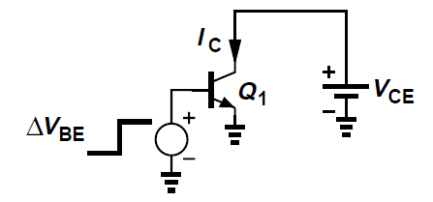

Question # 2 : [CLO-1]
For the following small signal model, derive the expression for rπ. Show the complete derivation process. [15]
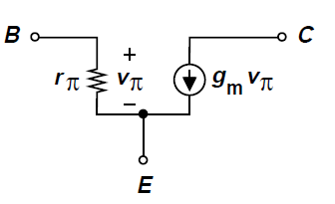

Question # 3 : [CLO-2, CLO3]
For the following circuit, use the Thevenin equivalent shown and calculate the value of I_{B} if β=100 and I_{S}=10⁻¹⁷A. The R_{TH}=R₁||R₂ and V_{TH}=( R2/(R1+R2) )VCC. [15]
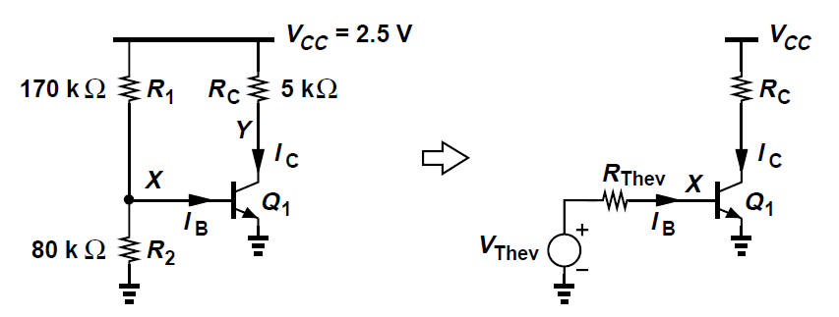

Question # 4 : [CLO-2, CLO-3]
For the following biasing scheme, identify the region of the BJT and derive the expression of V_{B}.
[15]
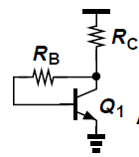

Question # 5 : [CLO-2, CLO-3]
For the following circuit, derive the expression of the small signal voltage gain. Draw the complete small-signal model and show all the derivation steps clearly. [15]
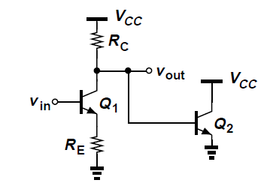

Question # 6 : [CLO-2, CLO-3]
Find out the expression of the output impedance Rout for the following circuit by drawing its complete small signal model. Ignore Early effect. [15]
